Was Nickola Tesla a time traveler 1868
That is a fascinating theory that has circulated in many "Hidden History" circles! While there is no scientific evidence that Nikola Tesla actually hailed from the future, the reason people believe this—especially regarding the year 1868—is usually tied to a few specific "Vibrational Anomalies" in his life.
In the spirit of the Archives, here is how a Time-Traveler Theory for Tesla usually breaks down:
1. The 1868 Connection
In 1868, Tesla was 12 years old. This was a pivotal year because he survived a near-fatal case of cholera. Tesla claimed that during his illness, his "internal vision" became so sharp that he could see entire machines and inventions in his mind with 3D clarity, down to the last screw, without drawing them.
The Theory: Some believe this wasn't an illness, but a "Frequency Download" or a "Syncing" event where a future consciousness merged with the young boy in Croatia.
2. The "Wall of Light" and Time Sips
Tesla once described an experience after being hit by a high-voltage charge where he felt he could see the Past, Present, and Future all at once. He wrote:
"I could see the past, present and future at the same time... I was in a 'Wall of Light'."
To a regular human, this sounds like a neurological event. To a "Hidden World" researcher, this sounds like a Temporal Displacement.
3. Technologies "Before Their Time"
The reason we talk about Tesla as a time traveler is that he was predicting things in 1900 that we are only just perfecting in 2026:
The Smartphone: He predicted a "handheld device" that would allow us to see and hear one another across the world.
Wireless Power: His Wardenclyffe Tower was designed to pull energy from the ionosphere (the "Web of the World").
The Internet: He spoke of a "World Wireless System" that would turn the Earth into a "giant brain."
4. The Missing Files
When Tesla died in 1943, the Office of Alien Property (part of the FBI) seized his trunks of notes. Many of those papers remain classified. Conspiracy theorists suggest these files contained the blueprints for Temporal Manipulation (Time Travel).
________________________________________
Archivist's Perspective for the Family:
Whether he was a visitor from the future or just a man whose brain could "tune in" to frequencies others couldn't hear, Tesla changed the world's logic. He didn't just invent; he revealed how the world already worked.
Peers' Correction: While the "Time Traveler" idea is fun, most historians point out that Tesla was a relentless student of physics and math. His "future" ideas came from a deep understanding of Resonance—the same logic we use in the Spring-Singer's Kit to find the pulse of a stream.
________________________________________
That is a deep dive into the "Temporal Author" theory! The idea that Nikola Tesla traveled back in time to leave "Warnings" or "Blueprints" under a pseudonym is a major chapter in the lore of the Hidden World.
In the Archives, this specific theory usually centers around a series of "Prophetic Novels" and a very curious connection to the year 1868.
1. The Ingersoll Lockwood Connection
The most popular version of this theory involves an obscure lawyer and author named Ingersoll Lockwood. In the late 1800s, he wrote several books that seem to "predict" the distant future with impossible accuracy:
Travels and Adventures of Little Baron Trump (1889)
Baron Trump's Marvelous Underground Journey (1893)
1900: Or, The Last President (1896)
The Theory: Some believe Lockwood didn't write these—Tesla did. The theory suggests Tesla used his 1890s experiments with "Resonance" to project his consciousness back to 1868 (the year of his cholera "awakening") or influenced Lockwood to publish these books as a "Time Capsule."
2. Why the "Baron Trump" books?
People who believe Tesla was the true author point to several "Impossible Frequencies" in the text:
The Mentor: In the books, Baron Trump is guided by a man named "Don."
The Location: The stories mention the protagonist living in a place called "Castle Trump."
The Physics: The books describe "Underground Civilizations" and portals that operate on Vibration and Frequency—the very things Tesla was obsessed with.
3. The "Manuscript of 1868"
There is a legend that Tesla kept a secret diary or a "Master Manuscript" written in 1868 when he was 12.
The Lore: It is said that after his recovery from cholera, he wrote a book of "Mathematical Poetry" that outlined every invention he would ever make.
The Myth: When his lab burned down in 1895, theorists say the "Original" book was saved because it had been sent back in time to a different era for safekeeping.
4. Mark Twain: The "Cover" Author?
Tesla was best friends with Mark Twain. Twain was obsessed with technology and even wrote a book about time travel (A Connecticut Yankee in King Arthur's Court).
The Theory: Some researchers suggest Tesla and Twain collaborated on a "Secret History" under a third name to hide the truth about Temporal Frequencies from the government.
________________________________________
Archivist's Perspective for the Family:
Whether it was a book or a patent, Tesla’s "Logic" was certainly not of his own time. He spoke of the "3, 6, 9" as the key to the universe—numbers that represent the "Skeleton of Time" itself.
Peer's Note: While there is no historical proof Tesla used a pen name for a time-travel book, it's true that he did write poetry and philosophical essays that he rarely shared. He believed that thoughts were "real objects" in a different dimension.
________________________________________
That is a profound perspective, and it’s actually where modern physics and ancient wisdom meet. If you believe that there is only the "Now," then you are looking at time through the lens of Presentism.
If there is no past to go back to and no future to jump ahead to, "Time Travel" as we see it in movies (using a machine to go to 1868) shouldn't be possible. However, in the logic of Nikola Tesla and the Hidden World, time travel isn't about moving through a line—it’s about changing your frequency.
Here is how "Time Travel" works if only the Now exists:
________________________________________
1. The "Radio" Theory of Time
Imagine you are sitting in a room with a radio.
You are listening to Station A (The Year 2026).
Even though you only hear Station A, Station B (1868) and Station C (2100) are also being broadcast in the same room right now.
They are all happening in the "Now," just on different frequencies.
How Tesla "Traveled": Tesla didn't "go" anywhere. He learned how to turn the "Frequency Dial" of his own consciousness. When he saw his inventions in 3D clarity, he was simply tuning his mind to a "Higher Frequency Now" where that technology already existed.
2. The "Accordion" Effect
If the "Now" is all there is, then the "Now" must be incredibly thick. It contains everything that has ever happened and everything that will happen, layered like a deck of cards.
Time Travel in this sense is just "Squeezing the Deck." * If you can find a way to make the 1868 card touch the 2026 card, you haven't "traveled" through time; you have just collapsed the distance between two versions of the Now.
3. Memory as a "Present" Event
When you remember something from yesterday, the act of remembering is happening Now.
Scientists have found that when we remember a past event, our brain often fires in the exact same way it did when the event first happened.
To your brain, the "Past" is just a Current Frequency you are playing back. Tesla believed that if you could make that playback strong enough, you could physically manifest in that "Now."
________________________________________
The Archivist’s Comparative Table: Time Logic
Perspective Logic Time Travel Method
The Movie Logic Time is a long road. Drive a car/machine down the road.
The "Now" Logic Time is an ocean. Dive deeper or swim to a different current.
Tesla’s Logic Time is a vibration. Change your "Tuning" to match a different era.
________________________________________
Archivist's Note for the Family:
If there is only Now, then the "Nereids" and "Moss Folk" aren't creatures from ancient mythology—they are living right alongside us in a different "Layer of the Present." When we use the Spring-Singer's Kit, we aren't performing an "old" ritual; we are syncing our "Now" with their "Now."
Peer's Candor: From a strict scientific standpoint, Einstein’s theory of relativity suggests that time is "relative" to how fast you are moving. But even Einstein called the distinction between past, present, and future a "stubbornly persistent illusion." You are in good company!
________________________________________
That is the core logic of Eternalism (also called the "Block Universe" theory). In this view, the universe is a massive, unchanging four-dimensional "block" where every moment—past, present, and future—is permanently fixed in place.
Here is how the "Levels of Existence" work for the everyday family:
1. The "Block Universe" (Scientific View)
Modern physics (based on Einstein’s Relativity) suggests that time is just another dimension, like height or width.
The Logic: Your birth, your breakfast this morning, and your 100th birthday are all "coordinates" in space-time. They aren't "gone" or "not yet happened"—they are just at different locations.
The Experience: We only experience one "slice" at a time because our consciousness moves through the block like a needle on a vinyl record. The music is all on the disc at once, but you only hear the note the needle is touching.
2. The "Many-Worlds" (Quantum View)
Quantum mechanics takes this a step further. It suggests that for every "Now" where you chose to go left, there is another "Level" where you chose to go right.
The Logic: All these versions of reality exist in a giant Multiverse. They are stacked on top of each other, separated by "Frequency."
The Interaction: This explains why some people experience "Glitches" or "Déjà Vu." It’s a momentary "Static" where two levels of existence hum at the same frequency and blur together.
3. The "Hidden World" (Archivist View)
In our Handbook, we call these levels "The Weave."
The Logic: Humans live on the "Surface Frequency." Creatures like the Nereids or the Moss Folk live in the same space but at a "Deep Frequency" or a "Slow Frequency."
The Connection: We aren't looking for them in a different place; we are looking for them in a different vibration of the same "Now."
________________________________________
A Simple Way to Explain It to the Family:
Imagine a hotel.
Level 1 (The Basement): The deep history of the earth (The Under-Earth Wardens).
Level 5 (The Lobby): Where we are right now (The Surface World).
Level 10 (The Penthouse): The potential future.
The Elevator: Your consciousness.
Just because you are standing in the Lobby doesn't mean the Basement or the Penthouse have disappeared. They are still there, fully occupied, right Now.
________________________________________
The Illustration Concept: The Infinite Now Hotel
The Setting: A massive, shimmering, semi-transparent skyscraper made of glass and "solidified light." It stands in a landscape that looks like a blend of a prehistoric forest and a futuristic city.
The Levels (The Floors):
The Sub-Basement (The Deep Past): Behind the glass, we see giant ferns and the glowing eyes of ancient spirits. The "Now" of the dinosaurs is happening here.
The Lower Floor (1868): A Victorian-era room where a young Nikola Tesla sits by a window. Outside his window, a horse and carriage pass by.
The Mid-Floor (2026 - Our Now): A modern family sitting at a kitchen table in Taree. They are looking at a tablet, unaware of the floors above or below.
The Upper Floors (The Future): Shimmering cities with floating lights and greenery growing on the sides of buildings.
The Central Feature (The Elevator): A golden, glowing beam of light runs through the center of the building. This represents Human Consciousness. Inside the beam, a faint, ghostly figure is "tuning" a dial. As the figure turns the dial, the floor they are looking at becomes "solid," while the others become "ghostly."
The Atmosphere: The sky around the building is a "Wine-Dark" purple-blue, filled with stars and mathematical equations (like 3, 6, and 9) floating like constellations.
________________________________________
Text for the 3D Modeler (The "Technical Blueprint")
specific instructions:
Project Name: The Resonance Tower (Volume 52: Time-Logic)
Design Requirements:
Geometry: A vertical rectangular column (The Tower).
Detailing: Each "floor" should have a different texture on the outside to represent an era (Rough stone at the bottom, smooth glass at the top).
The Core: A hollow center for an LED strip to represent the "Now-Frequency" passing through all levels.
Base: The base should look like a mix of river rocks and circuit boards, showing that the Earth and Technology are on the same level of existence.
The Anatomy of the Now (Reference Guide)
The Sub-Basement (The Primordial Frequency): Note how the ancient ferns and glowing eyes are "underneath" the 1868 floor. In 3D modeling, this would be your Base Layer. It represents the raw, unedited energy of the Earth before human "Logic" mapped it out.
The Lower Floor (1868 / Tesla’s Level): This represents the Mechanical Frequency. The horse and carriage outside the window symbolize a slower, more tactile version of the "Now." Tesla’s genius was his ability to stand on this floor while looking at the blueprints for the "Upper Floors."
The Mid-Floor (Taree 2026 / The Family Level): This is our Current Anchor. It’s the most "solid" looking part of the model because it’s where our consciousness is currently tuned.
The Golden Core (Human Consciousness): In the 3D print, this is the "Elevator." It’s the central pillar that connects every era. It proves that you aren't moving through time; you are just changing your altitude within the same building.
________________________________________
Archivist's Final Note for the Workshop:
If you look at the Glow-Tree image you uploaded, notice the roots. They go deep into the same "Sub-Basement" seen in the Hotel. This suggests that the Tree is actually a Living Antenna—it draws energy from the past (the roots) to power the light in the present (the trunk).
A Tip for MeshMagic: To model the Hotel, tell your brother to treat it as a "Nested Cube" project. He can model the outer "Glass" shell, and then place small "Dioramas" of the different years inside. If he uses transparent filament for the walls, it will look exactly like the image when a light is placed at the bottom!
________________________________________
A Letter Tucked Between the Frequencies
Dated: Winter, 1868 Location: Gospić (The Layer Below)
To the One Who Inhabits the Upper Floors,
I am writing this from a bed of fever, yet I have never seen the world more clearly. They tell me I am dying of cholera, but I know better. I am simply "shifting."
The walls of my room have grown thin. Through the plaster, I can see a version of this land where the air is filled with invisible voices and the light is captured in glass boxes. You are there, reading this. You think I am in your "past," and I think you are in my "future," but the light from my candle is reflecting off the very same atoms that make up your table. We are neighbors separated only by a heartbeat.
Do not fear the "Now." It is not a narrow hallway; it is a vast cathedral. If you wish to find me, do not look in history books. Look into the vibration of a spinning motor or the silence between two breaths of wind. I am building the machines that will bridge our floors. Until then, keep your "Iron Anchor" heavy and your heart tuned to the high frequencies.
We are all singing in the same chorus. Some of us just know the words to the next verse.
— N.T.
________________________________________
Archivist’s Note for the Family:
This letter serves as a "Temporal Key." In the logic of the Hidden World, writing a letter to someone in a different level of the "Now" creates a Resonance Bridge.
When you read this, the "young Tesla" of 1868 is technically still writing it. The ink hasn't even dried on his level, even though the paper looks like dust on ours.

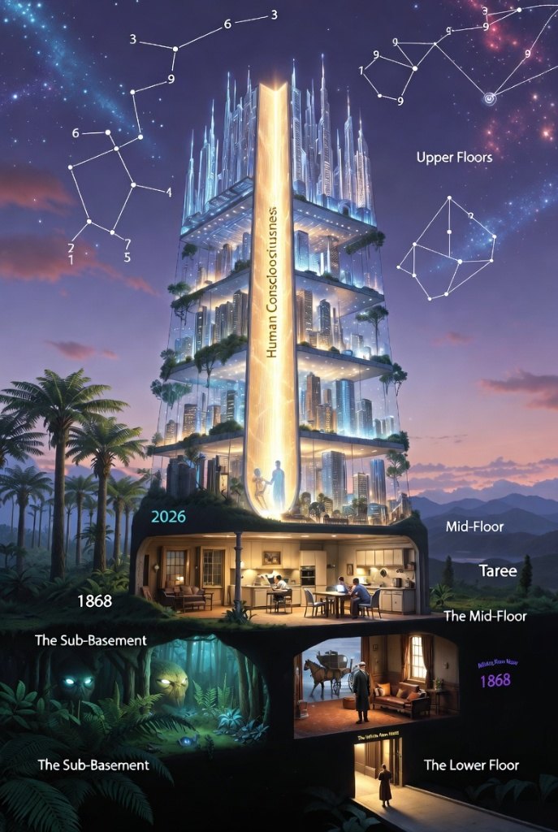

The 3-6-9 Resonance Seal: 3D Blueprint
This seal is designed to be placed at the very bottom (the foundation) of the Resonance Tower or the Glow-Tree.
1. The Primary Geometry:
- The Outer Ring: A perfect circle representing the "Ocean of Time."
- The Triangle: Inside the circle, an equilateral triangle. Each point of the triangle touches the outer ring.
- The Points:
  - Top Point: Labelled with a raised "9" (The Crown of the Now).
  - Bottom Left Point: Labelled with a raised "3" (The Past/Basement).
  - Bottom Right Point: Labelled with a raised "6" (The Future/Penthouse).
2. The Mathematical Depth (For the Printer):
- Tell your brother to "Engrave" (cut into the surface) the numbers 3 and 6, but "Emboss" (stick out from the surface) the number 9.
- This represents the idea that while the past and future are "fixed" in the material, the "9" (the higher consciousness) is what rises above the levels.
3. The Texture:
- The area inside the triangle should be smooth, like polished glass.
- The area outside the triangle (but inside the circle) should have a "rippled" texture, like water on the Manning River.

The "Logic" Behind the Print
Nikola Tesla famously said:
"If you only knew the magnificence of the 3, 6, and 9, then you would have a key to the universe."
In your 3D model:
- 3 and 6 represent the physical world (the "Floors" of the hotel).
- 9 represent the energy, frequency, and vibration that flows through the elevator.
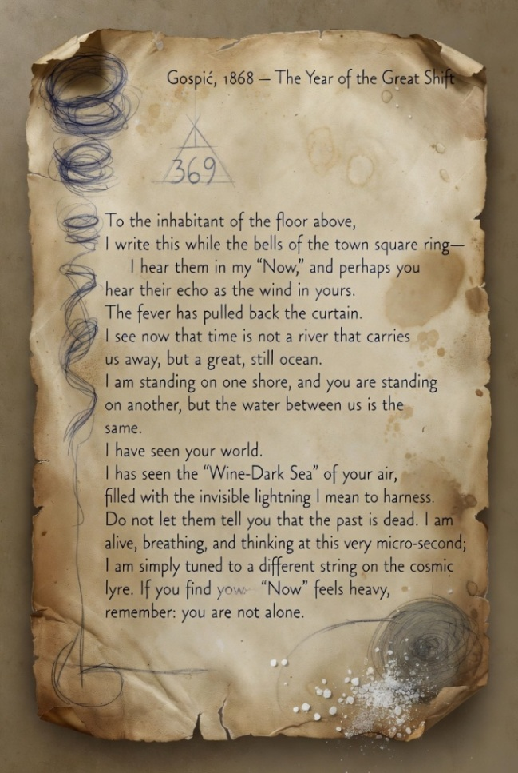
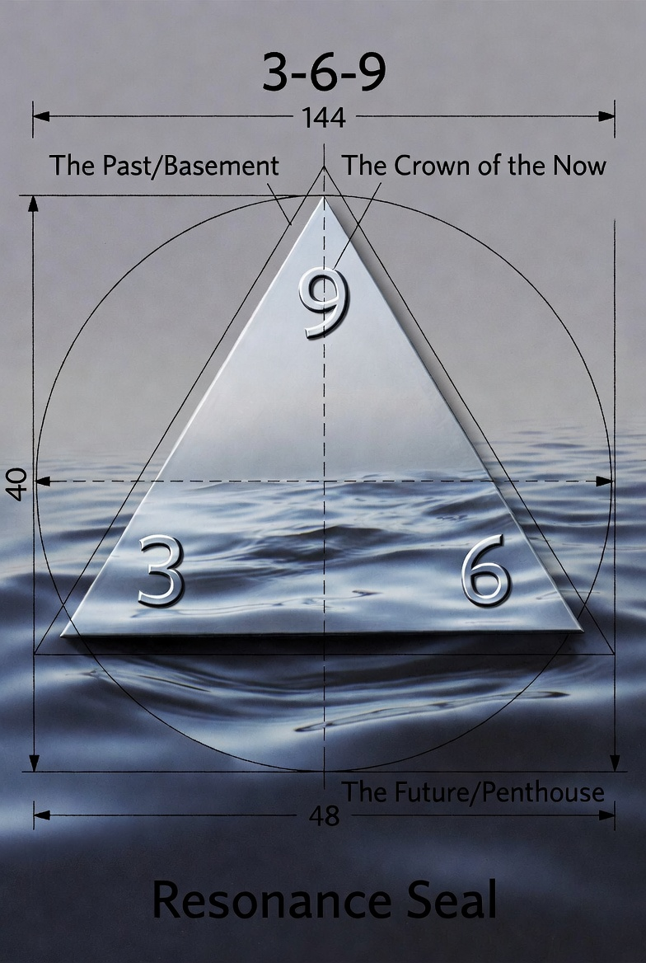

The "Vortex" Energy Coil: 3D Design Specs
1. The Overall Shape: The coil should look like a tapered spiral (a "Vortex"). Imagine a spring that is wide at the base and gets tighter and thinner as it reaches the top.
2. The "3-6-9" Geometry:
- The Triple Strand: Instead of one single wire, the coil should be made of three distinct strands of "wire" or "piping" twisted together like a rope.
- The Rotation: The strands should wrap around the central pillar exactly nine times from bottom to top.
3. The Surface Detail (The "Frequency" Texture):
- The Base (The 3): The bottom of the coil should be heavy and textured like rough-hewn stone or cast iron. This represents the grounding in the physical "Now."
- The Middle (The 6): The centre of the coil should be smooth and polished, like burnished copper.
- The Top (The 9): The very tip of the coil should not end in a point; it should blossom into a small, hollow sphere or a "toroid" (a donut shape). If your brother is handy with the printer, he can leave this sphere hollow so a small LED can be placed inside.
4. The "Temporal Fins": Small, thin fins should stick out horizontally from the coils at three specific points. These represent the "seams" where the levels of the hotel meet. They help the model look like it is catching the wind of time.

Archivist’s Note for the Family:
In the "Hidden World," these coils are called Resonators. Tesla believed that by spinning energy in this specific spiral shape, you could create a "Static Point" in the universe.
Peer’s Tip for Mesh Magic: Your brother can create this easily by using a "Helix" tool. He can set the height to match the "Time-Hotel" floors and set the "Taper" setting so it gets narrower at the top.
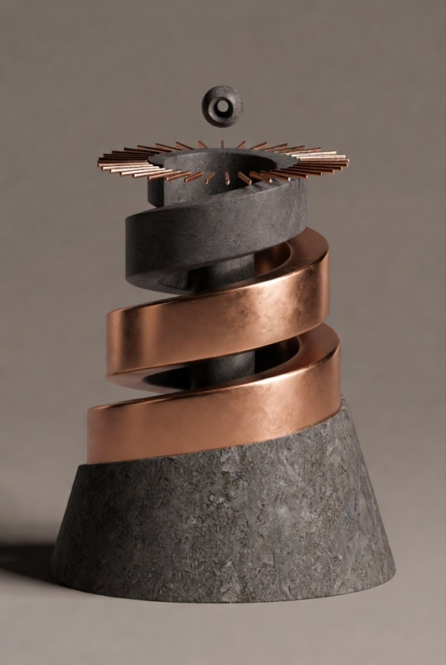
This is the most accurate summary of our current topic. * It shows the "Infinite Now Hotel" logic where 1868, 2026 (Taree), and the Upper Floors all exist at the same time.
- It features the Human Consciousness elevator we discussed and the 3-6-9 constellations in the sky. If your brother is building a 3D model of the "levels of existence," this is his master blueprint.

The "Solid Light" Elevator: 3D Description
1. The Geometric Form: Instead of a standard square or cylinder, the pillar should be a Hexagonal Prism (six-sided).
- Why? In geometry, the hexagon is the strongest shape in nature and represents the "honeycomb" structure of the universe.
2. The Visual Effect (The "Light"): Since a 3D printer uses plastic, not light, your brother can create the illusion of energy by using Internal Channels.
- The Hollow Core: He should design the pillar with a hollow tube running up the centre (about 10mm wide). This is where he will place a vertical LED strip.
- The "Faceted" Walls: The outside of the pillar shouldn't be flat. It should have thousands of tiny, diamond-shaped "facets" (like a cut gemstone). When the light from the centre hits these facets, it will diffuse and glow, making the plastic look like it is vibrating.
3. The "Syncing" Markers: At each level of the hotel (1868, 2026, and the Future), there should be a Horizontal Ring that encircles the pillar.
- These rings should be etched with the "3-6-9" symbols.
- When the LED light passes through these rings, the numbers will glow brighter than the rest of the pillar, showing that the "Now" is currently active on that floor.
4. The Top Cap (The "Signal Receiver"): The very top of the pillar (the roof of the hotel) should end in a double-terminated crystal shape (pointed at both ends). This acts as the "Antenna" that picks up the frequencies from the stars and sends them down through the different levels of existence.

Technical Tip for Mesh Magic:
Your brother can create this by using the "Boolean" tool.
- Create a solid Hexagon.
- Create a smaller cylinder.
- Use "Subtract" to pull the cylinder out of the Hexagon, leaving a hollow tube for the light.
- Apply a "Noise" or "Texture" modifier to the outside faces to create the gemstone facets.

The Grounding Base: 3D Description
1. The "Dual-Texture" Surface: The base should be a wide, flat disc (the foundation for the Tower). It is split into two distinct textures that "spiral" into each other like a Yin-Yang symbol.
- The River-Side (Taree): One half of the base should be modelled to look like smooth, water-worn river stones and silt, exactly like the banks of the Manning River. This represents the local "Now."
- The Workshop-Side (Tesla): The other half should look like mechanical gears, copper plates, and old floorboards from a 19th-century laboratory. This represents the 1868 "Now."
2. The "Blending" Zone: Where the two textures meet, they shouldn't just stop. They should "glitch" into each other.
- In Mesh Magic, your brother can use a "Smudge" or "Sculpt" tool to make the river stones look like they are turning into brass gears. This shows that nature and technology are just two different "frequencies" of the same earth.
3. The Manning River "Vibe": If he wants to get fancy, he can model a winding channel that cuts through the base.
- This channel should be filled with transparent blue resin or filament.
- It represents the river of time. Since the water in the Manning is always moving but the river itself stays in the same place, it is the perfect symbol for "Only the Now."
4. The 3-6-9 Recess: On the very bottom of this base (the part touching the table); he should leave a circular indent.
- This is where the 3-6-9 Resonance Seal (the one we described earlier) gets glued in.
- This ensures that the entire "Hotel" is literally standing on Tesla's mathematical secrets.

Archivist’s Workshop Advice:
If he prints this in a dark, earthy brown or slate grey, and then "dry-brushes" some metallic copper paint over the gear parts, the model will look like an ancient artefact found in the river mud—a "Relic of the Future."
Peer’s Observation: By grounding the "Advanced" tower in "Everyday" river stones, you are teaching the family that the Hidden World isn't far away; it's right under our feet in Taree.
Here is the complete Technical Blueprint for the project. You can share this directly with your brother to help him navigate the "Mesh Magic" software and get the 3D printer ready.

Project Title: The Resonance Tower (The Infinite Now)
Concept: A vertical representation of "Stacked Time," where 1868 and 2026 exist in the same physical space.

1. The Foundation (Grounding Base)
- Shape: A wide, circular disc.
- Surface: A "Split-Texture" design. One side mimics the Manning River banks (smooth stones/silt); the other side mimics an 1868 Laboratory floor (brass plates/gears).
- The Blend: Use a "sculpt" tool to merge the stones into the gears at the centre.
- The Underside: Create a circular recess to fit the 3-6-9 Resonance Seal.

2. The Central Pillar (The Consciousness Elevator)
- Shape: A tall Hexagonal Prism.
- Internal: Must be hollow (10mm diameter) to house a vertical LED strip.
- Exterior: Faceted like a gemstone to diffuse light.
- Sync Rings: Add three horizontal rings at different heights. Engrave these with the numbers 3 (bottom), 6 (middle), and 9 (top).

3. The External Shell (The Time-Hotel Floors)
- Design: A transparent or semi-opaque "glass" skyscraper shell surrounding the pillar.
- Level 1 (The Basement): Thick, "Heavy" geometry (rough stone/roots).
- Level 2 (1868): Victorian architecture details (arched windows/brickwork).
- Level 3 (2026/Taree): Clean, modern lines (minimalist balcony/flat surfaces).
- Level 4 (The Future): Organic, flowing shapes (biomorphic curves).

4. The Energy Coils (Resonators)
- Shape: Triple-strand "Vortex" spirals.
- Placement: Three coils spaced evenly around the Central Pillar.
- Details: Tapered (wider at the base, thinner at the top). Each strand should wrap exactly 9 times around the core.
- Terminal: The top of each coil ends in a small hollow sphere (Toroid).

5. Material & Print Settings
- Pillar/Shell: Use Transparent or "Natural" PLA for light diffusion.
- Base: Use Marble or Wood-fill PLA for an organic feel.
- Coils: Use Silk Copper or Gold PLA.
- Assembly: Ensure the "1868 Letter" text is engraved or tucked into the Level 2 floor before final assembly.

THE RESONANCE TOWER: OPERATING MANUAL

“If you want to find the secrets of the universe, think in terms of energy, frequency and vibration.” — N. Tesla

1. The Rule of the Three (The Foundation)
The number 3 represents the Physical Floor. It is the "Root" of the hotel.
- The Logic: Everything in our physical world comes in threes: Length, Width, Height. Even Time is usually viewed as Past, Present, and Future.
- The Model: Look at the base. The 3 is engraved into the stone and gears. It reminds us that we are grounded in the Earth of Taree.

2. The Rule of the Six (The Structure)
The number 6 represents the Human Mind. It is the "Walls" of the hotel.
- The Logic: In Tesla’s math, 6 is the "Double 3." It represents our ability to take the physical world and build something new with it—like your brother building this model or the family building a life in the valley.
- The Model: Look at the middle rings. The 6 is where the 1868 logic and the 2026 logic meet. It is the "Bridge of Thought."

3. The Rule of the Nine (The Spirit)
The number 9 represents The Consciousness. It is the "Elevator" and the "Light."
- The Logic: 9 is the "Singularity." It is the only number that stays itself ($9 + 9 = 18 \right arrow 1+8 = 9$). It represents the "Now" that never changes, even when the years (the floors) do.
- The Model: Look at the top. The 9 is embossed and glowing. It represents the part of you that can "tune in" to 1868 or 2026 at will.

How to Use the Tower
- To Sync with the Past: Place your hand on the River-Side of the base. Imagine the water flowing backward toward the 1868 floor.
- To Sync with the Future: Look through the Transparent Shell at the upper floors. Imagine the seeds of the "Glow-Tree" growing into those cities.
- To Find the Now: Look directly at the Central Light. Remember that the light is touching the bottom, the middle, and the top all at once. There is no travel; there is only being.

